# **Biodivercity**

1. Introduction
   1. Get to know the data
   2. What we solved?
2. Research and visualize
   1. conversion status
   2. protection status of species
   3. Endangered species
   4. Threatened species
   5. Species of concern
   6. Most detailed
   7. Parks that Vermivora Bachmanii is endangered
   8. Most species are concerned
   9. Conservation status in Yosemite National Park
3. Conclusions

## **Introduction**

In recent centuries we hurt animals and make a lot of species extinct so we have responsibility to conserves the species we have.

In this report I analyst National Parks Service about endangered species in different parks and their status.

### **1.1 Get to know the data**

We have two CSV files in this data analyst observation and species and columns include:

* **scientific_name** : Scientific names of species
* **park_name**: Name of parks
* **observations**: How many time that species observed
* **category**: Category of species
* **conservation_status** : What conservation species at

### **1.2 Hands on data**

In this analysis I perform cleaning the duplicate and null data, joining data sets so we can answer these questions:

1. How many species we protected and how is conversion statuses?
2. what is most protected species among their own and all of the species?
3. What are most endangered species?
4. What are most threatened species?
5. What are most species of concern?
6. What is the most specie and park in every conservation status?

## **Analysis**

### **conversion status**

There are 5633 species that are not protected and other conversion status is :

**Conservation status size**

Endangered 16

In Recovery 4

No Intervention 5633

Species of Concern 161

Threatened 10

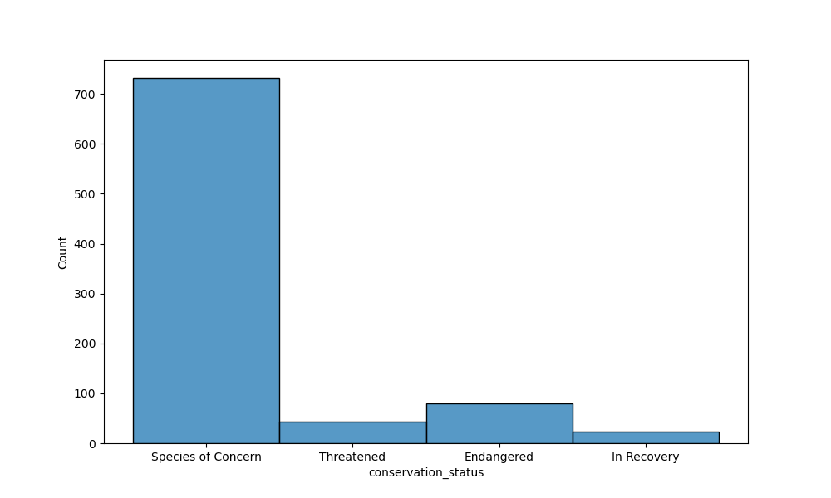

### **protection status of species**

Only 1% of Vascular plant and 2% of Nonvascular plant are protected and this is really low percentage among other species, and most protected species are Mammals and birds in their own category.

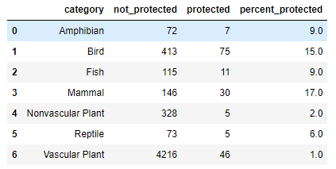

You can see what is most protected species among all of the species and Birds have the most attention with about 42%.

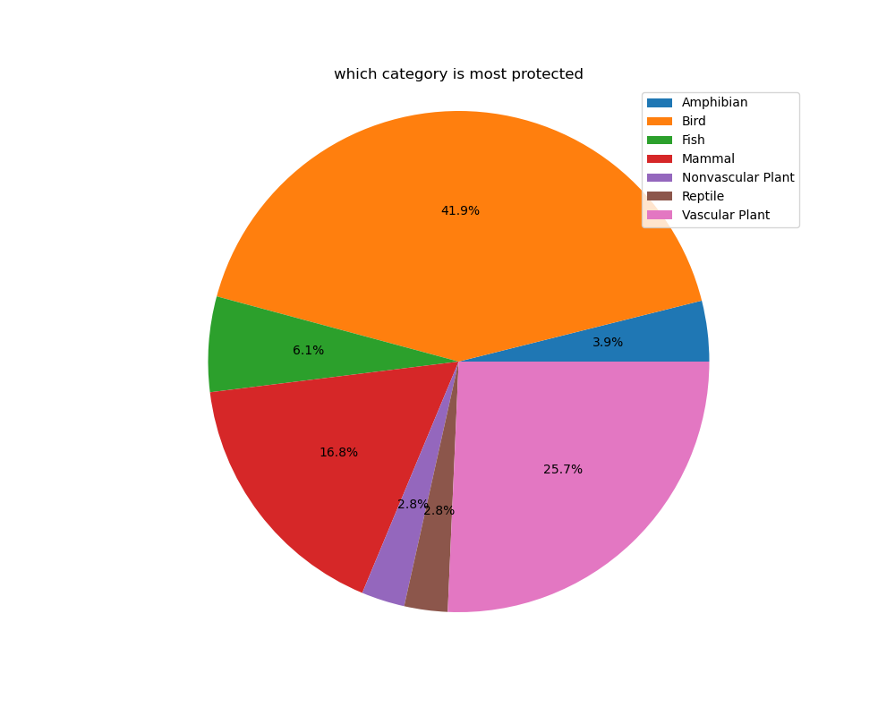

### **Endangered species**

Endangered species should be are most concern and there is more than half (55 percents) of endangered species are Mammals and Vascular plants and Amphibians only get 10% together.

### **Threatened species**

Humans make living hard for other species and threaten their life in so many ways but you can see we make water so polluted that most threaten species are fishes and their life is about twice treated than others.

### **2.5 Species of Concern**

Birds are most concerned species along with Mammals and Vascular plants.

### **2.6 Brief details**

**Endangered**

Most Endangered Specie is: **Vermivora bachmanii**

Park That has The Most Endangered Species Is: **Yosemite National Park**

Animal Category That is the most Endangered Is: **Vascular Plant**

**In Recovery**

Most In Recovery Specie: **Pelecanus occidentalis**

Park That Has The Most In Recovery Species Is: **Yosemite National Park**

Animal Category That is the most In Recovery Is: **Mammal**

**Concern Species**

Most Species of Concern Species is: **Zizia trifoliata**

Park That Has The Most Species of Concern Species Is: **Yosemite National Park**

Animal Category That is the most Species of Concern Is: **Vascular Plant**

**Threatened Species**

Most Threatened Species Are: **Ursus arctos horribilis**

Park That Has The Most Threatened Species Is: **Yosemite National Park**

Animal Category That is the most Threatened Is: **Vascular Plant**

### **2.7** **Parks that Vermivora Bachmanii is endangered**

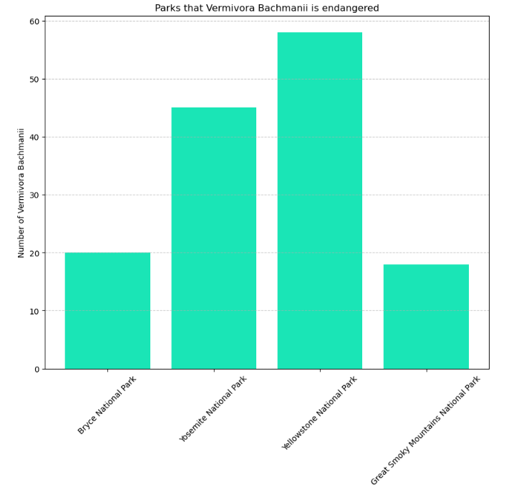

The most endanger specie is vermivore bachmaniiand and Yellowstone nation park is where these species are in danger

### **2.8 Most species are concerned**

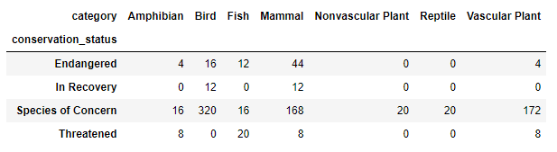

Among all the conservation status we have covered most species in concern.

### **2.9** **Conservation status in Yosemite National Park**

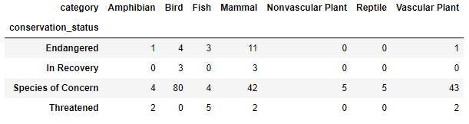

Yosemite national park get the most of all conservation statuses so it’s good to see how they are doing and they concern most of the species they have.

## **Conclusions**

Birds are most species they protect and concern but we missing huge number of species.

Mammals are the most species that are in danger so we should concern them more liked birds.

Fishes are most threatened species but the least concerned so we really take attention and research about it.